#### **1. Introduction**

Academic success in engineering disciplines is often influenced by multiple factors, including attendance, theoretical understanding, and practical application. Understanding the relationship between these aspects can help educators and students make data-driven decisions to optimize learning outcomes. This study aims to analyze the correlation between **attendance, theoretical performance, and practical performance** across two semesters in an undergraduate AI & ML program.

#### **2. Purpose & Objectives**

The primary objective of this study is to explore the **correlation between attendance and academic performance** in different subjects across two semesters. Specifically, we aim to:

* Investigate **attendance correlations** across different subjects.
* Assess **how attendance in one semester influences attendance in subsequent semesters**.
* Examine **correlations in theory subject performance** across semesters.
* Analyze **practical subject performance and its interdependencies**.
* Provide insights on how students' engagement in one domain (attendance, theory, or practicals) impacts their overall academic trajectory.

#### **3. Methodology**

The study utilizes **correlation matrices** to identify relationships between attendance, theoretical scores, and practical performance. Additionally, **linear regression models** are used to explore **predictive relationships between predecessor and successor subjects** across semesters. The study is based on real-world attendance and academic performance data collected from students in an undergraduate program.

### **4.1 Attendance Analysis**

#### **4.1.1 Semester 1 Attendance Trends**

* Attendance patterns indicate strong correlations between subjects.
* **Mathematics-1 and Java-1 attendance (0.84)** show that students who attend math classes consistently also maintain attendance in programming courses.
* **Physics and Software Engineering attendance (0.81)** reinforce the trend of structured learning habits.
* A moderate correlation of **0.66** is observed between **Mathematics-1 & Mathematics-2** and **Java-1 & Java-2**, indicating a continuation of attendance patterns across semesters.

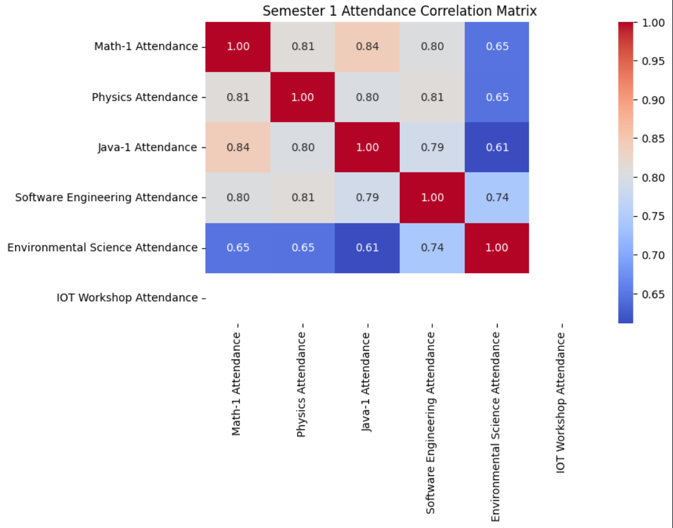

#### **4.1.2 Semester 2 Attendance Trends**

* Correlations weaken in Semester 2, suggesting independent attendance behaviors.
* **Mathematics-2 and Data Structures attendance (0.78)** show that students focusing on mathematics also prioritize programming subjects.
* **Physics and Electronics attendance (0.62)** highlight the conceptual continuity between these subjects.

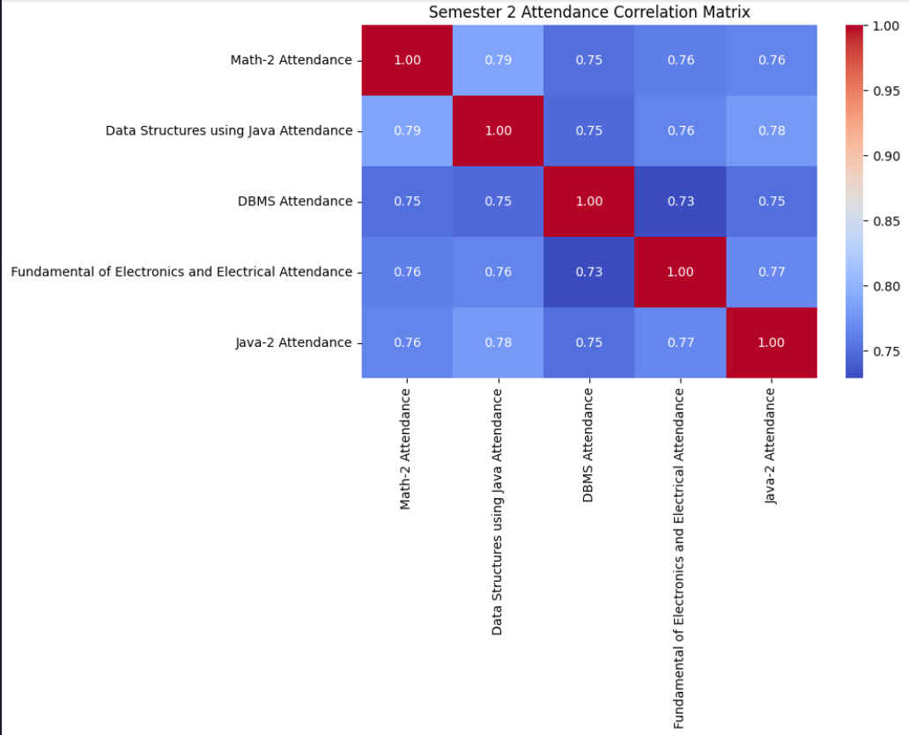

Predecessor-Successor Pair: Attendance

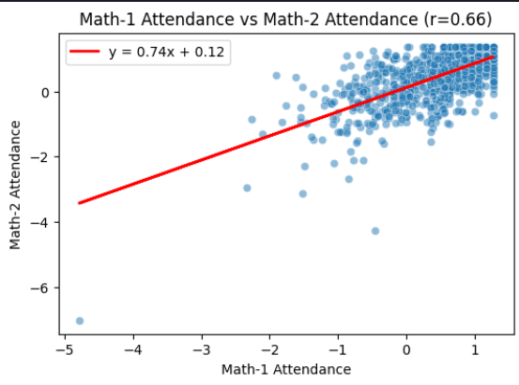

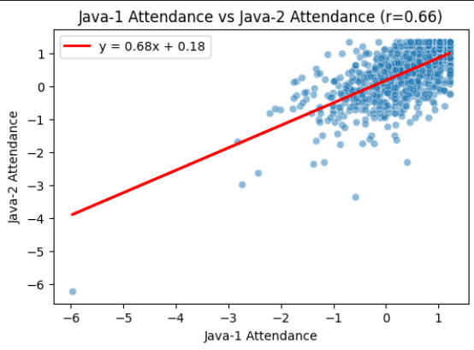

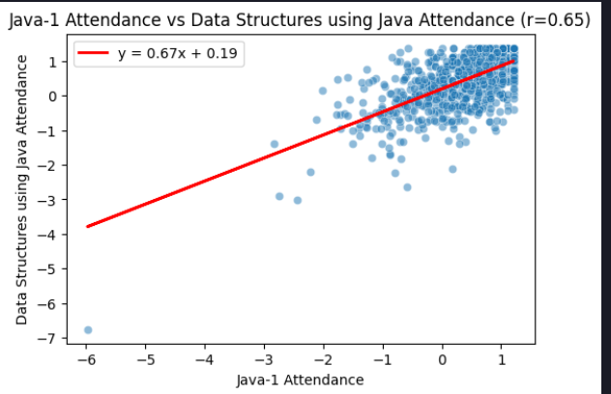

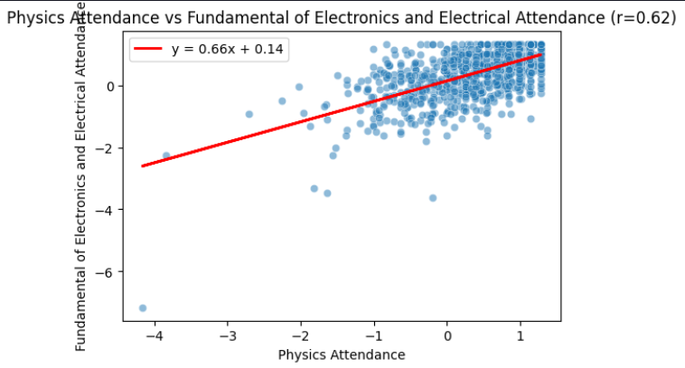

### **4.2 Theory Performance Analysis**

#### **4.2.1 Semester 1 Theory Trends**

* **Mathematics-1 and Physics Theory (0.73)** indicate strong interdependencies due to overlapping problem-solving skills.
* **Physics and Software Engineering Theory (0.78)** emphasize the importance of structured analytical thinking.
* Strong predecessor-successor correlations: **Mathematics-1 & Mathematics-2 (0.75)** and **Java-1 & Java-2 (0.81)** show foundational knowledge is key to success in subsequent courses.

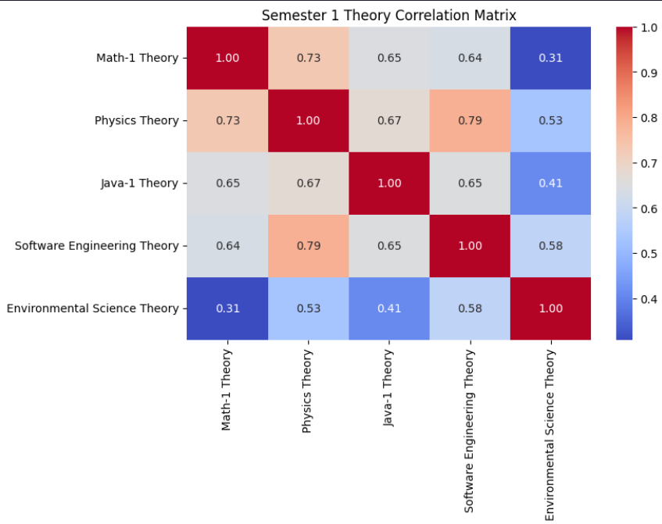

#### **4.2.2 Semester 2 Theory Trends**

* **DBMS and Data Structures Theory (0.78)** suggest computational subjects are interrelated.
* **Physics and Electronics Theory (0.79)** highlight scientific continuity.
* **Java-1 and Data Structures Theory (0.64)** indicate early programming concepts impact later performance.

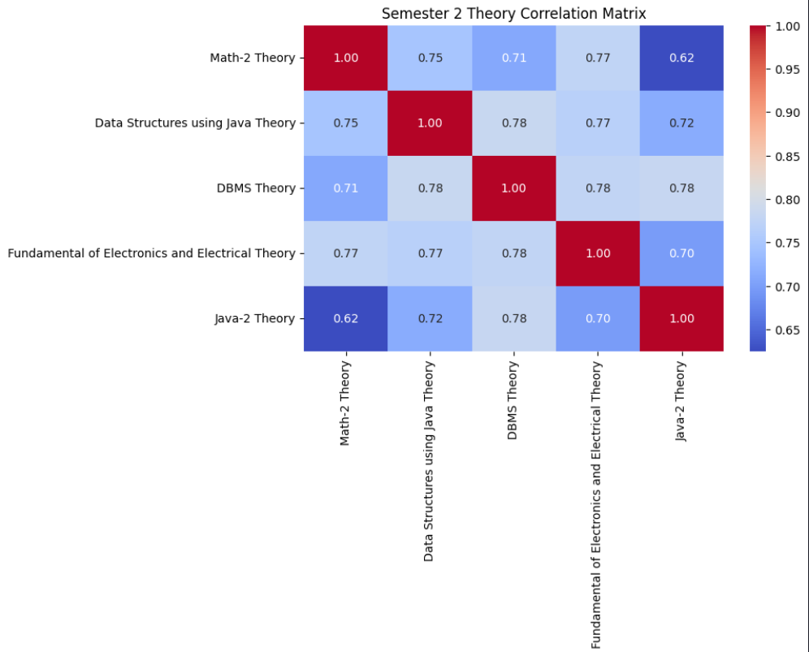

Predecessor-Successor Pair: Theory

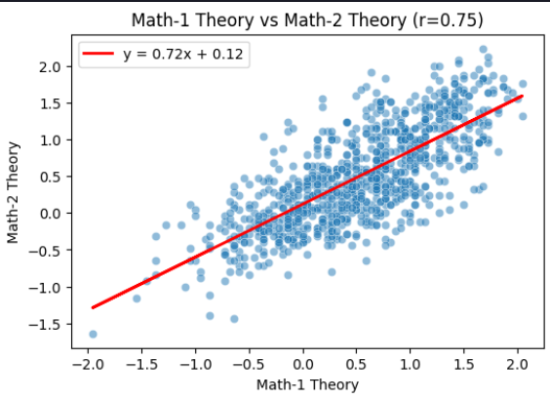

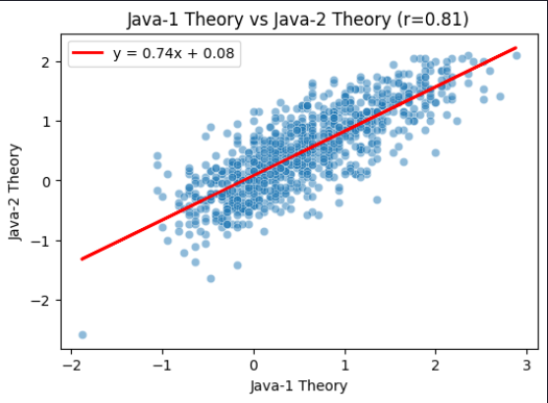

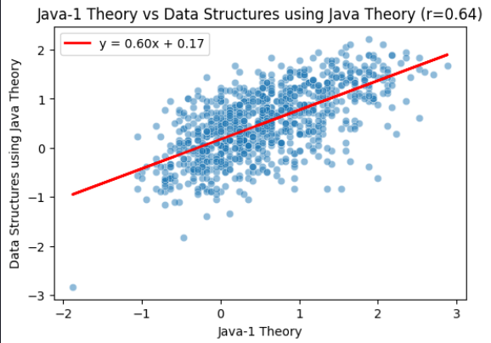

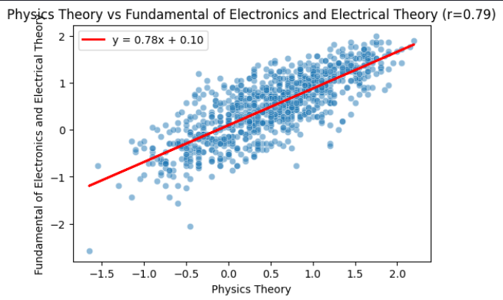

### **4.3 Practical Performance Analysis**

#### **4.3.1 Semester 1 Practical Trends**

* Practical correlations are weaker than theory and attendance trends.
* **Java-1 Practical and IoT Workshop Practical (0.39)** suggest a hands-on learning pattern.
* **Java-1 & Java-2 Practical (0.39)** and **Physics & Electronics Practical (0.36)** indicate inconsistent skill application.

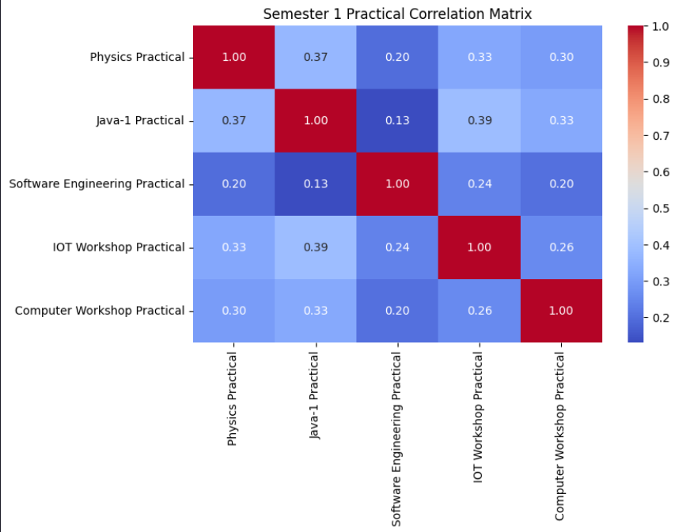

#### **4.3.2 Semester 2 Practical Trends**

* **Data Structures Practical and Java-2 Practical (0.94)** show highly transferable programming skills.
* **DBMS Practical and Java-2 Practical (0.89)** reinforce database management and programming overlap.
* **DBMS Practical and Data Structures Practical (0.90)** emphasize their complementary nature.

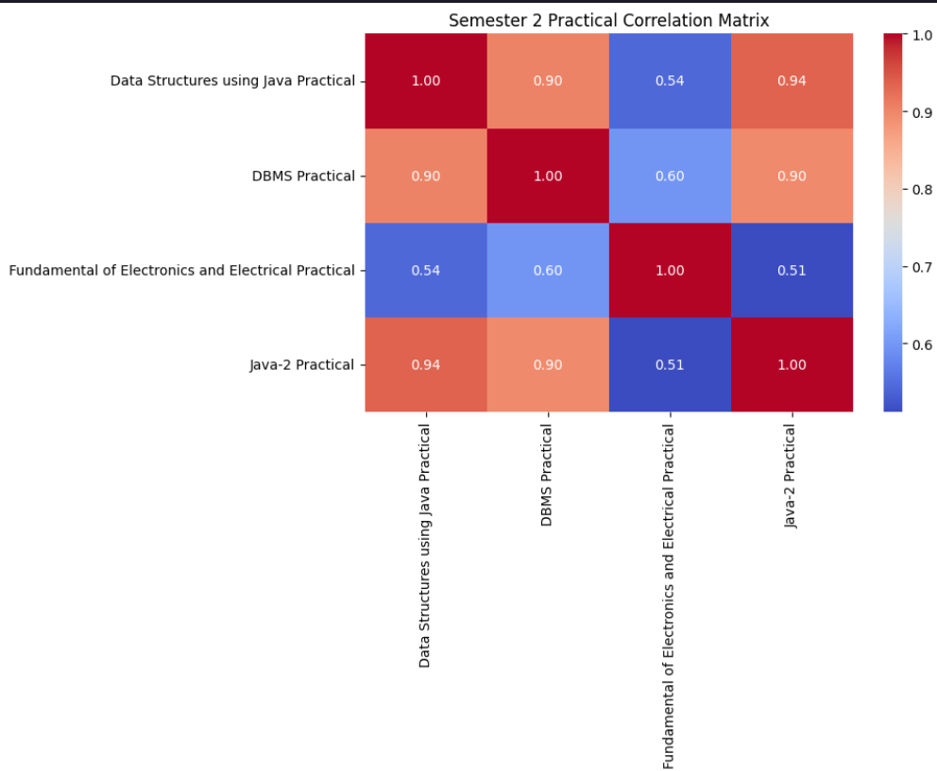

Predecessor-Successor Pair: Particular

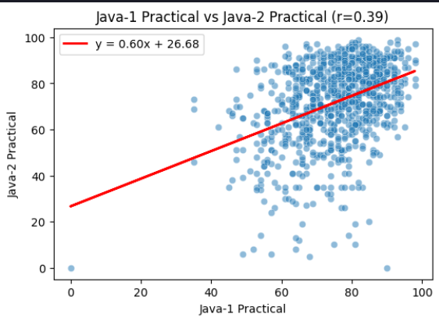

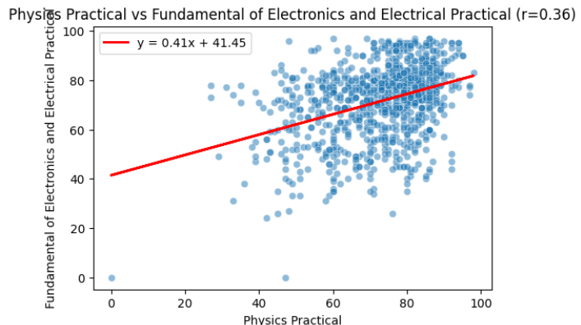

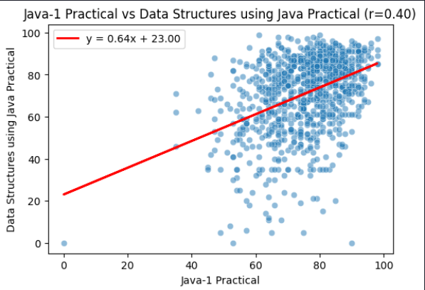

### **4.4 Conclusion**

* **Attendance and Performance Correlation:** Strong attendance in early semesters positively impacts academic performance. Mathematics and Java attendance correlations suggest that students disciplined in math also develop strong programming habits.
* **Subject Interconnections:**
  + **Mathematics and Physics:** A strong correlation between Mathematics-1 and Physics theory scores (0.73) suggests that students excelling in math are more likely to perform well in physics.
  + **Programming and Computational Subjects:** Java-1 and Data Structures theory scores (0.64) highlight the progressive learning nature of programming courses.
  + **Physics and Electronics:** High correlation (0.79) indicates that physics fundamentals are essential for success in electronics.
* **Practical Skill Retention:** Practical performance shows weaker correlations, suggesting that students struggle to consistently apply hands-on knowledge across semesters. Strengthening project-based learning could improve retention.

### **4.5 Key Educational Implications**

1. **Encouraging early attendance discipline** improves academic outcomes.
2. **Curriculum should reinforce conceptual continuity** (e.g., aligning physics and electronics courses more closely).
3. **Project-based learning strategies** should be implemented to enhance practical knowledge retention and application.